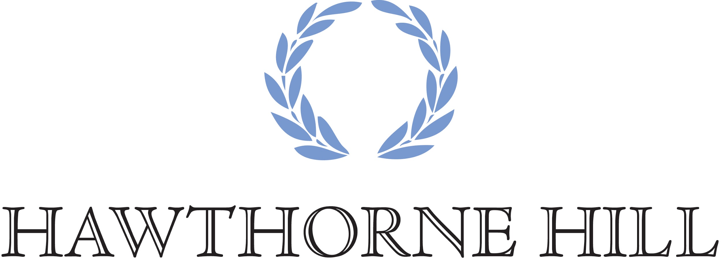

Release, Assumption of Risk, Waiver of Liability and Indemnity Agreement

*This document waives important legal rights. Please read carefully before signing.

I AGREE for myself, and/or my children, my/our administrators and assigns, in consideration for my (and/or my children’s) participation in activities at or with Hawthorne Hill, LLC.

I am VOLUNTARILY choosing to participate in equine activities as a rider, driver, handler, lessee, owner, agent, spectator, volunteer, boarder and/or trainer. I am fully aware and realize that horse sports involve dangerous risks of accident, loss and serious bodily injury including but not limited to broken bones, head injuries, trauma, pain, suffering or death (“Harm”). I fully understand that this release covers, but is not limited to, inherent risks of an equine activity which means a danger or condition that is an integral part of an equine activity, including but not limited to, and of the following:

* The propensity of an equine to behave in ways that may result in injury, death, or
loss to persons on or around the equine;

* The unpredictability of an equine’s reaction to sounds, sudden movement,
unfamiliar objects, persons, or other animals;

* Hazards, including, but not limited to, surface or subsurface conditions;

* A collision with another equine, another animal, a person, or an object;

* The potential of an equine activity participant to act in a negligent manner that may
contribute to injury, death, or loss to the person of the participant or to other persons,
including but not limited to, failing to maintain control over an equine or failing to
act within the ability of the participant.

I AGREE to release Hawthorne Hill, LLC, its successors or assigns, officials, officers, directors, employees, agents, personnel, volunteers and affiliated organizations from all claims including, but not limited to, claims for money or property, disability, covenants, actions, suits, causes or action, obligations, debts, costs, expenses, attorneys’ fees, judgments, orders and liabilities of whatsoever kind or nature in law, equity or
otherwise, whether now known or unknown, suspected or unsuspected, and whether concealed or hidden, including but not limited to any state or federal statutory or common law claim or remedy of any kind whatsoever arising out of or in any way connected with any Harm to me or my horse and for any Harm caused by me or my horse to others, even if the Harm resulted, directly or indirectly, from the negligence of Hawthorne Hill, LLC.

I AGREE to expressly assume all risks of Harm to me or my horse, including Harm resulting from the negligence of Hawthorne Hill, LLC or the Hawthorne Hill, LLC activity, and specifically agree to the applicable state statute/law regarding equine/farm animal activity liability and signed posting (if any), in any state in which I or my child participates in a Hawthorne Hill, LLC activity. A true copy for all state statutes in effect at the time of the execution of this agreement is attached hereto and incorporated herein by reference as if set out fully in the text of this document.

I AGREE to indemnify (that is, to pay any losses, damages, or costs incurred by) Hawthorne Hill, LLC and to hold them harmless with respect to claims for Harm to me or my horse, and for claims made by others for any Harm caused by me or my horse while participating in any activities at Hawthorne Hill, LLC.

I AGREE that neither I, nor anyone claiming through me, will hereafter bring, commence, prosecute or maintain, or cause or permit to be brought, commenced, prosecuted or maintained, any suit or action, either at law or in equity, in any court in the United States or in any state thereof, or elsewhere, against Hawthorne Hill, LLC, its successors or assigns, for, on account of, arising out of, or in any way connected with any Harm to me or my horse, and that neither I, nor anyone claiming through me, will enforce, prosecute, or recover upon, or attempt to enforce, prosecute, or recover upon, any claim or right of action whatsoever, which I, or anyone claiming through me, may now have or hereafter assert, in any way connected with claims for Harm to me or my horse, and for claims made by others for any Harms caused by me or my horse while participating in any Hawthorne Hill, LLC activities.

I AGREE this Agreement is the entire agreement of the parties, and supersedes all prior oral and written understandings and agreements. This Agreement may be modified only by a written amendment signed by both parties.

I AGREE that if any provision of the Agreement is found to be invalid or illegal by a court of competent jurisdiction, the remaining provisions shall be construed as if the affected provision had not been included in order to effectuate the intent of the parties.

In the event this form is signed by the parent/guardian of a child, then all representations and acknowledgements herein are expressly made by, for, and on behalf of the parent/guardian and child.

By signing below, I acknowledge that I enter into this release after having read the same, and place my signature hereto of my own free voluntary act and deed. By signing below, I represent to Hawthorne Hill, LLC that I fully understand its contents, that I do not need any further explanation, and I waive any further explanation.

__________________________________ ____________________________________
Hawthorne Hill Representative Participant/Guardian/Boarder
(please specify)

__________________________________ ____________________________________
Date Printed Name

____________________________________
Date

Address:_____________________________________________________________________________

Home Phone:_____________________________ Mobile:___________________________________

Emergency Contact/Phone:__________________________________________________________

Email:______________________________________ Date of Birth:__________________________

